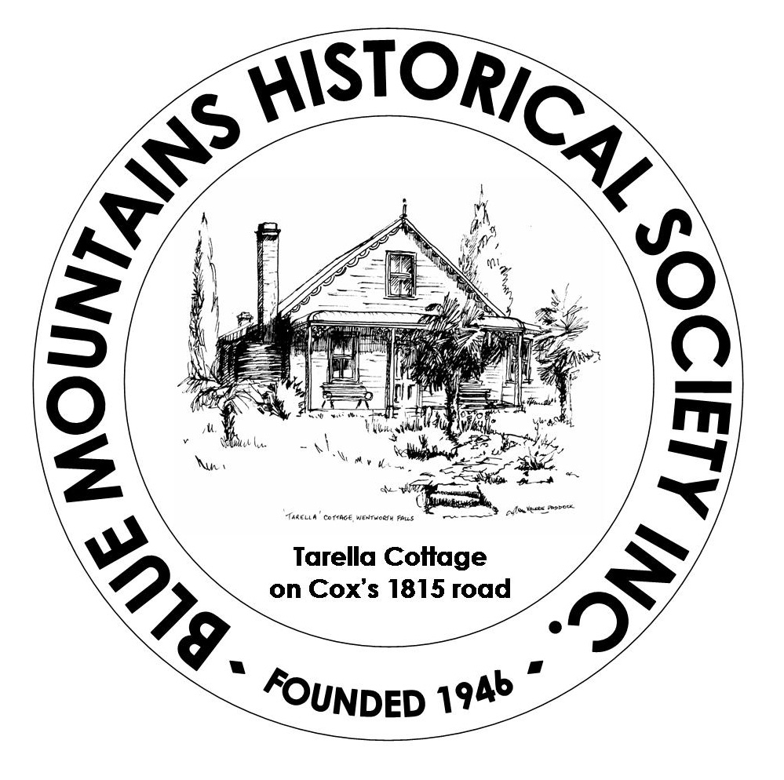
Blue Mountains Historical Society Inc.
ABN: 77 023 588 990

Affiliated with
Royal Australian Historical Society
National Trust of Australia (NSW)

TARELLA OPEN DAY
SUNDAY 28 OCTOBER 2018

On Sunday 28 October 2018, the Blue Mountains Historical Society’s 19th century cottage museum, Tarella, at 99 Blaxland Road, Wentworth Falls will be Open for viewing from 10.00 am until 3.00 pm.
What new delights can you find in our rooms? We have recently added interesting new pieces to our collection. Come along and see them.
The Sun Room Gallery is buzzing with the new exhibition, Armistice and World War 1: Impact on the Blue Mountains and Communities. Items are displayed in the Gallery and the Research Centre. Come along and examine the impact of the War on Australian communities both during and after World War 1.
If it is a fine day we will also be running our ever-popular garden stall.
Devonshire teas and soup are available in the Research Centre for a small charge.
Entry charges to Tarella are $5.00 for adults and $2.00 for children. Entry to the exhibition is free with entry to Tarella.

