Outdoor SANTA photos in HARTLEY...

Santa will be coming to visit us all in the paddocks at Hartley again this year and you are invited to bring the whole family (including your four legged ones) for some special candid outdoor photos with Santa. We will be at the following venues and times:
Sat 30 Nov - 9-10.30am Adams Shed, Hartley
Sun 1 Dec - 9-10.30am The Lolly Bug
Sat 7 Dec - 9-10.30am Adams Shed, Hartley
Sun 8 Dec - 9-10.30am The Old Hartley Post Office Cafe.
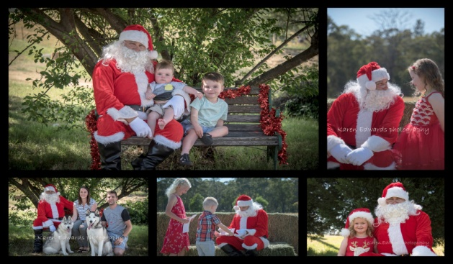
Mini photo sessions are still just $30 with photos emailed or for an additional $5 placed on disc ready for collection the following week from that venue. No need to book, just come along and wait in turn.

For more details go to www.facebook.com/karenedwardsphotographyhartley or call 0414 857 764.

